POWER BI ANALYTICAL DASHBOARD SCREENSHOTS

1. Home Page

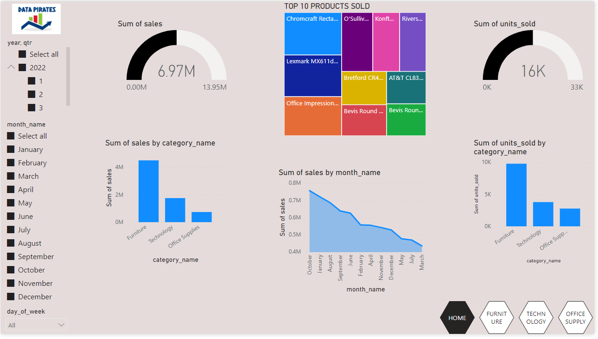

Selecting Quarter 1

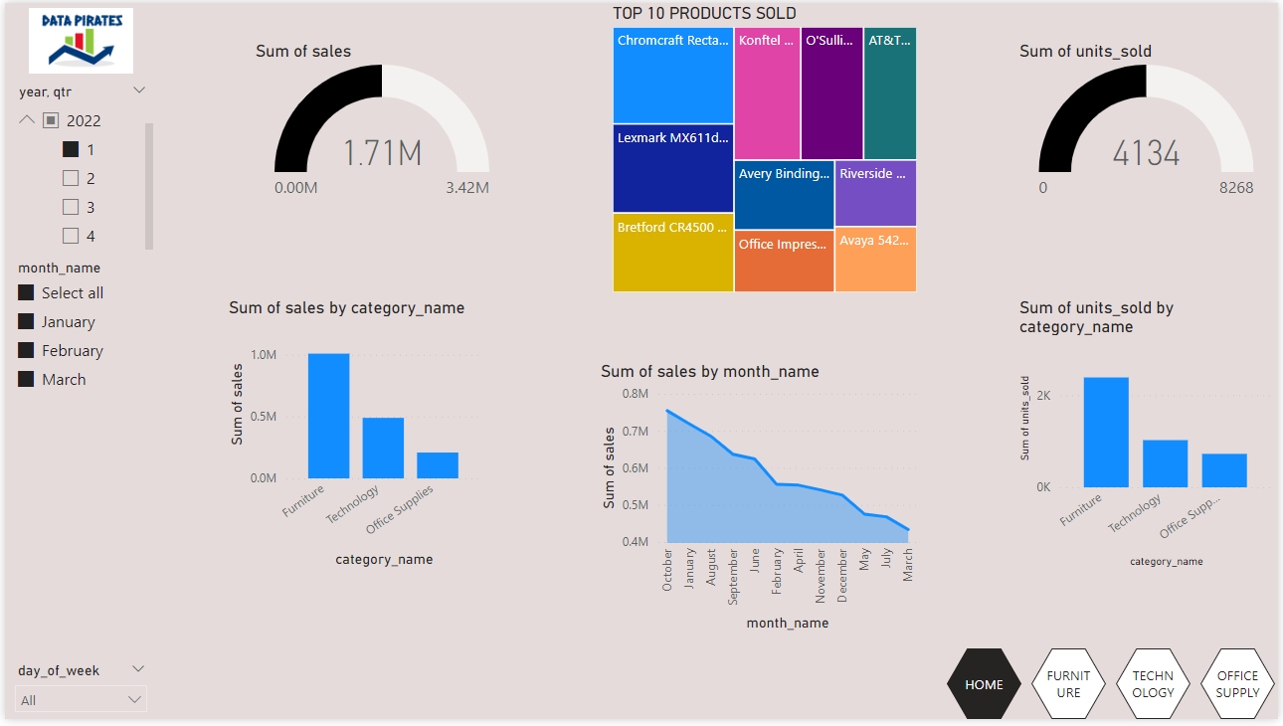

Selecting specific day (SUNDAY) in quarter 1

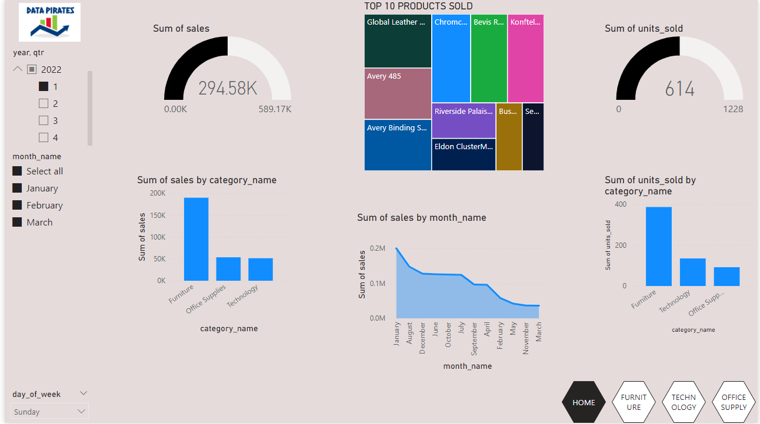

1. Furniture Page

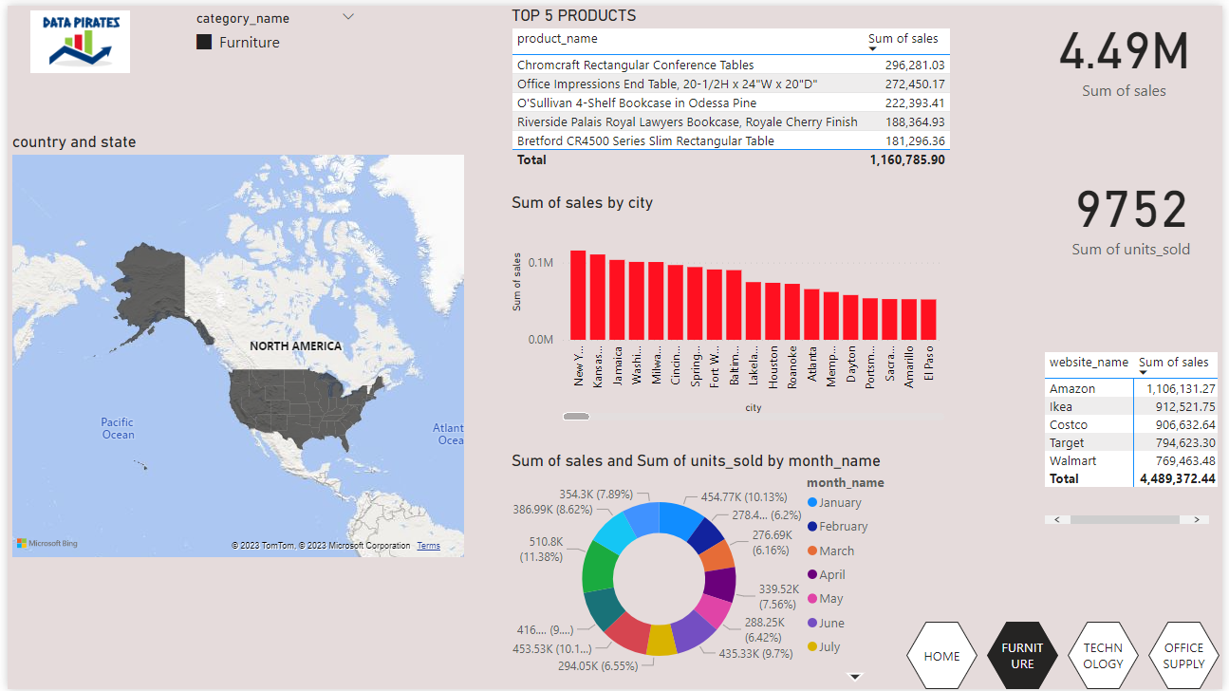

Selecting specific State ( CALIFORNIA)

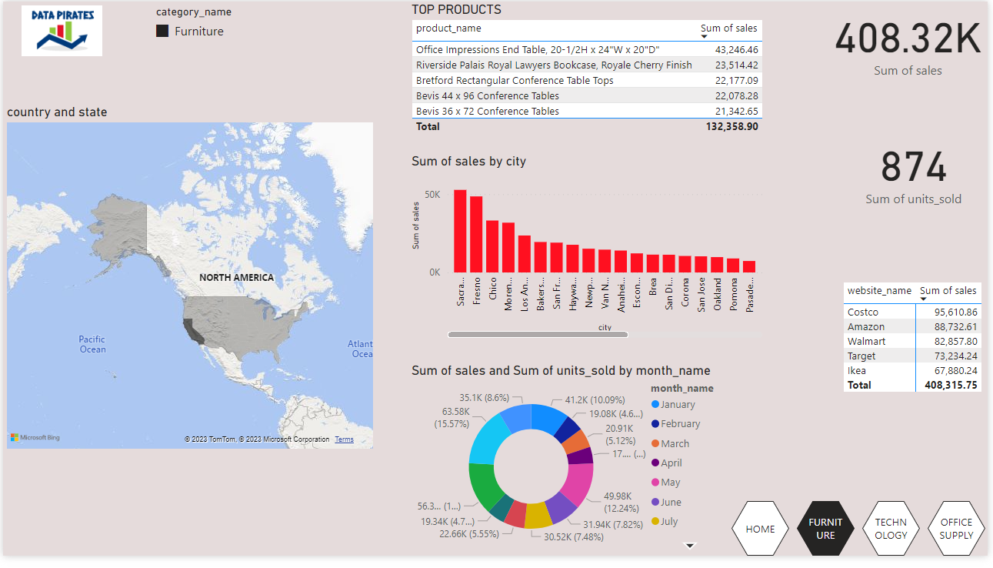

SELECTING SPECIFIC CITY IN NEW YORK

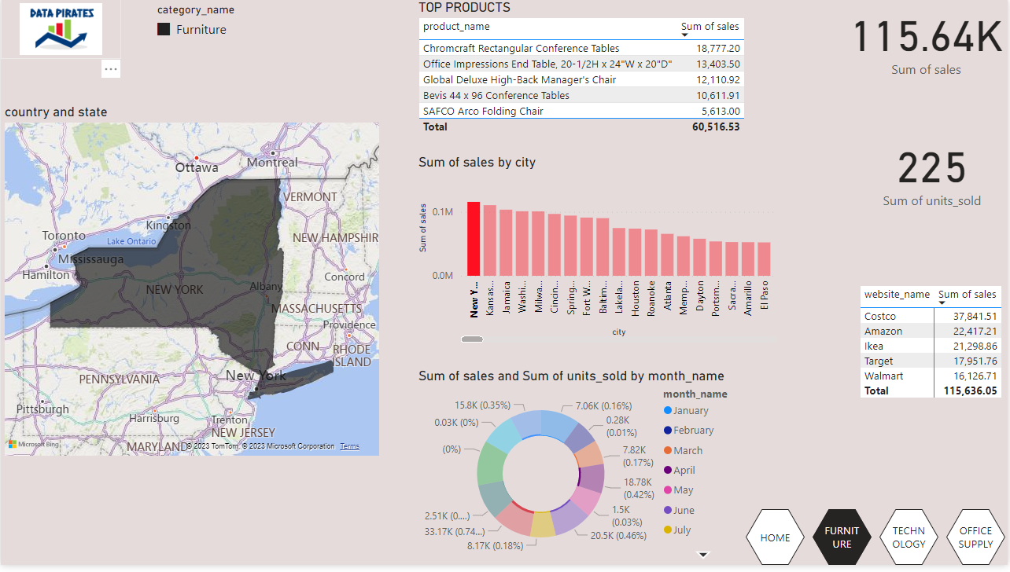

1. TECHNOLOGY PAGE

Tech sales in Arizona

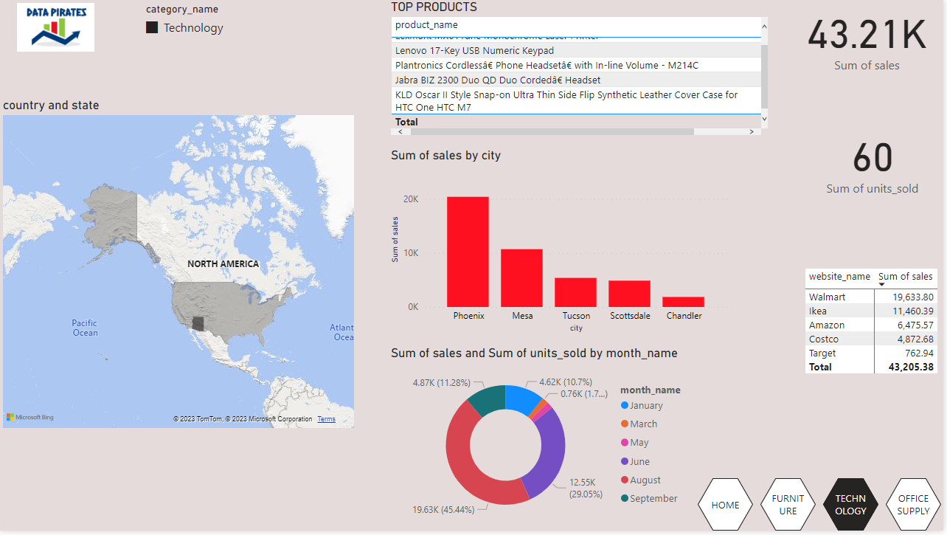

1. OFFICE SUPPLY PAGE

Office supplies in TEXAS

